**Answer Sheet for Java Exam 2022**

**Que 1)**

**Ans:**

**import java.util.*;**

**public class ArrayListExample**

**{**

**public static void main(String[]args)**

**{**

**ArrayList<String> ck = new ArrayList<String>();**

**ck.add("chetan");**

**ck.add("dhiraj");**

**ck.add("rohan");**

**ck.add("kiran");**

**ck.add("tushar");**

**ck.add("aviral");**

**for(String fri:ck)**

**System.out.println(ck);**

**}**

**}**

**Screenshot:**

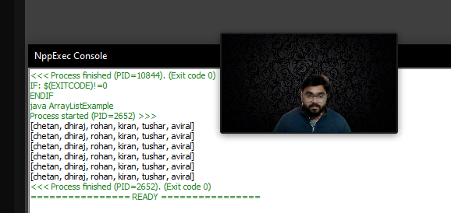

**Que 2)**

**Ans:**

**import java.util.Scanner;**

**public class BankAccount**

**{**

**public static void main(String[] args){**

**System.out.println("Welcome to the bank");**

**}**

**public double balance = 0.0;**

**public int deposits = 0;**

**public double withDrawals = 0;**

**public double annualInterestRate = 0;**

**public double serviceCharge = 1;**

**public double accountBalance(double bal, double intRate)**

**{**

**balance = bal;**

**annualInterestRate = intRate;**

**return balance;**

**}**

**public void deposit(double amount)**

**{**

**balance +=amount;**

**deposits++;**

**}**

**public void withDrawal(double amount)**

**{**

**balance -= amount;**

**withDrawals++;**

**}**

**private void calcInterest()**

**{**

**double monthlyInterestRate;**

**double monthlyInterest;**

**monthlyInterestRate = (annualInterestRate / 12);**

**monthlyInterest = balance * monthlyInterestRate;**

**balance = balance + monthlyInterest;**

**}**

**protected void monthlyProcess()**

**{**

**balance -= serviceCharge;**

**calcInterest();**

**withDrawals = 0;**

**deposits = 0;**

**serviceCharge = 0;**

**}**

**public double getBalance()**

**{**

**return balance;**

**}**

**}**

**public class SavingsAccount extends BankAccount**

**{**

**public SavingsAccount(double balance, double annualInterestRate)**

**{**

**super();**

**}**

**public void withDrawal(double amount)**

**{**

**if(balance >= 25)**

**super.withDrawal(amount);**

**else**

**System.out.println("Your account is inactive. Your balance needs to be over $25." );**

**}**

**public void deposit(double amount)**

**{**

**if(balance >= 25)**

**super.deposit(amount);**

**else**

**System.out.println("Your account is inactive. Your balance needs to be over $25." );**

**}**

**protected void monthlyProcess()**

**{**

**if(withDrawals > 4)**

**serviceCharge++;**

**else;**

**}**

**}**

**Que 3)**

**Ans:**

**class shape**

**{**

**void draw();**

**{**

**System.out.println("Shape draw()");**

**}**

**void erase()**

**{**

**System.out.println("Shape erase()");**

**}**

**}**

**class Circle extends Shape**

**{**

**void draw()**

**{**

**System.out.println("Circle draw()");**

**}**

**void erase()**

**{**

**System.out.println("Circle erase()");**

**}**

**}**

**class Triangle extends Shape**

**{**

**void draw()**

**{**

**System.out.println("Triangle draw()");**

**}**

**void erase()**

**{**

**System.out.println("Triangle erase()");**

**}**

**}**

**class Square extends Shape**

**{**

**void draw()**

**{**

**System.out.println("Square draw()");**

**}**

**void erase()**

**{**

**System.out.println("Square erase()");**

**}**

**}**

**public class Shapes**

**{**

**public static Shape randshape()**

**{**

**switch((int)(Math.random()*3));**

**{**

**case 0:return new Circle();**

**case 1:return new Square();**

**case 2: return new Triangle();**

**default: System.out.println("default");**

**return new Shape();**

**}**

**}**

**public static void main (String [] args)**

**{**

**Shape s[] = new Shape(9)**

**for (int i= 0; i< s.length; i++ s(i) = randshape(); for(int i= 0 ; i < s.length; i++) s(i).draw());**

**}**

**}**

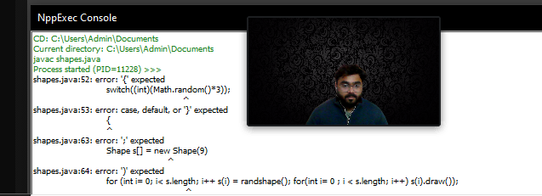

**Que 4)**

**Ans:**

**class GrandParents**

**{**

**String GrandFatherName;**

**String GrandMotherName;**

**public GrandParents(String grandFatherName, String grandMotherName) {**

**GrandFatherName = grandFatherName;**

**GrandMotherName = grandMotherName;**

**System.out.println("GrandFatherName: "+grandFatherName);**

**System.out.println("GrandMotherName: "+grandMotherName);**

**}**

**}**

**public class Q4_1_GrandParents**

**{**

**public static void main(String[] args) {**

**GrandParents gp = new GrandParents("Uttreshwar","Ganga");**

**}**

**}**

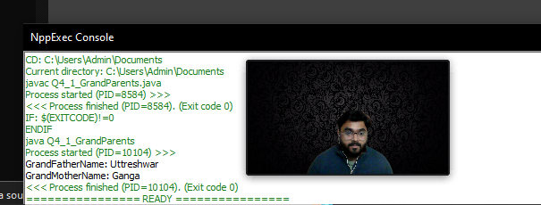

**Q4.2**

**class GrandParentss**

**{**

**String grandFatherName;**

**String grandMotherName;**

**public GrandParentss(String grandFatherName, String grandMotherName)**

**{**

**this.grandFatherName=grandFatherName;**

**this.grandMotherName=grandMotherName;**

**System.out.println("Name of Grand Father is : "+grandFatherName);**

**System.out.println("Name of Grand Mother is : "+grandMotherName);**

**}**

**}**

**class Parentss extends GrandParent {**

**String FatherName;**

**String MotherName;**

**public Parentss(String FatherName, String MotherName, String grandFatherName, String grandMotherName) {**

**super(grandFatherName, grandMotherName);**

**this.FatherName = FatherName;**

**this.MotherName = MotherName;**

**System.out.println("Name of Father is : " + FatherName);**

**System.out.println("Name of Mother is : " + MotherName);**

**}**

**}**

**public class Family**

**{**

**public static void main(String[] args) {**

**Parentss p = new Parentss("Rajendra","Ayodhya","Uttreshwar","Ganga");**

**}**

**}**

**\*\*\*OutPut\*\*\*\*\*\***

**Q4.3**

**class GrandParent**

**{**

**String grandFatherName;**

**String grandMotherName;**

**//Constructor of class GrandParent**

**public GrandParent(String grandFatherName, String grandMotherName)**

**{**

**this.grandFatherName=grandFatherName;**

**this.grandMotherName=grandMotherName;**

**System.out.println("Name of Grand Father is : "+grandFatherName);**

**System.out.println("Name of Grand Mother is : "+grandMotherName);**

**}**

**}**

**class Parent extends GrandParent**

**{**

**String FatherName;**

**String MotherName;**

**public Parent(String FatherName,String MotherName,String grandFatherName, String grandMotherName)**

**{**

**super(grandFatherName, grandMotherName);**

**this.FatherName=FatherName;**

**this.MotherName=MotherName;**

**System.out.println("Name of Father is : "+FatherName);**

**System.out.println("Name of Mother is : "+MotherName);**

**}**

**public Parent(String grandFatherName, String grandMotherName) {**

**super(grandFatherName, grandMotherName);**

**}**

**}**

**public class Child extends Parent {**

**public Child(String FatherName, String MotherName, String grandFatherName, String grandMotherName) {**

**super(FatherName, MotherName, grandFatherName, grandMotherName);**

**}**

**public static void main(String args[]) {**

**Child c = new Child("Rajendra", "Ayodhya", "Uttreshwar", "Ganga");**

**}**

**}**

